**Week 9 Session3- Lab**

**Question:-**

Create a Database & Table Using MySQL Command-Line Client.

● Create a database with the name StudentManagementSystem.

Create a table with named Student with attributes:

● StudentID (Primary Key)

● FirstName

● LastName

● DateOfBirth

● Gender

● Email

● Phone

Create a table with name Course with attributes:

● CourseID (Primary Key)

● CourseTitle

● Credits

Create a table with named Instructor with attributes:

● InstructorID (Primary Key)

● FirstName

● LastName

● Email

Create a table with named Enrollment with attributes:

● EnrollmentID (Primary Key)

● EnrollmentDate

● StudentID(Foreign key)

● CourseID(Foreign Key)

● InstructorID(Foreign key)

Create a table with named Score with attributes:

● ScoreID (Primary Key)

● CourseID (Foreign key)

● StudentID (Foreign Key)

● DateOfExam

● CreditObtained

Create a table with named Feedback with attributes:

● FeedbackID (Primary Key)

● StudentID (Foreign key)

● Date

● InstructorName

● Feedback

**Assignment 1.**

For this assignment, please use the same tables created in your previous lab session.

**Task 1:**

Update the Student table with the following information:

Change the email to 'jane_Smith@example.com'

Where FirstName is 'Jane' and LastName is 'Smith';

Update the Instructor with the following information:

Change the email to 'sunilrawat@example.com'

Where FirstName of the instructor is 'Sunil' and LastName is 'Rawat';

**Task 2:**

Delete record from the Student table on following condition:

Delete student/students records from the Student table where last name is Smith.

**Task 3:**

List the student whose first name starts with J.

Submission: Create an SQL script file containing your solutions for all tasks (queries).

Name the file "lab_assignment1.sql" Provide comments above each query to

indicate the task number and the query's purpose.

**Assignment 2.**

Database Schema:

Consider a simple database with one tables: Employee

Employee Table:

● Columns: emp_id (Primary Key), first_name, last_name, age, email

**Task 1:**

Insert Data

Write an SQL INSERT statement to insert data into the Employee table.

**Task 2:**

Retrieving Data

Write an SQL SELECT statement to retrieve the first_name and last_name of all

employees from the Employee table.

**Task 3:**

Filtering Data

Write an SQL SELECT statement to retrieve the first_name, last_name, and age of

employees who are older than 30 years.

**Task 4:**

Updating Data

Write an SQL UPDATE statement to increase the age of employees by 1 year for all

employees older than 25.

Submission:

Create an SQL script file containing your solutions for all tasks (queries). Name the file

"lab_assignment2.sql" Provide comments above each query to indicate the task

number and the query's purpose.

**Assignment 3.**

Database Schema:

Consider a simple database with one tables: BankAccount

BankAccount Table:

● Columns: account_id (Primary Key), account_holder_name, account_balance

**Task 1:**

Insert Data

Write an SQL INSERT statement to insert data into the BankAccount table.

**Task 2:**

Retrieving Data

Write an SQL SELECT statement to retrieve the account_holder_name and

account_balance of all account holders from the BankAccount table.

**Task 3:**

Filtering Data

Write an SQL SELECT statement to retrieve the account_holder_name and

account_balance where the account_balance is more than 30,000.

**Task 4:**

Updating Data

Write an SQL UPDATE statement to change the account_balance of the account holder

whose ID is 103 to 50,000.

Submission:

Create an SQL script file containing your solutions for all tasks (queries). Name the file

"lab_assignment3.sql" Provide comments above each query to indicate the task

number and the query's purpose.

**Answers:-**

**Assignment 1.**

create database lab_assignment1;

use lab_assignment1;

CREATE TABLE Student (

StudentID VARCHAR(10) PRIMARY KEY,

FirstName VARCHAR(25),

LastName VARCHAR(25),

DateOfBirth DateTime,

Gender VARCHAR(25),

Email VARCHAR(30) UNIQUE,

Phone VARCHAR(25)

);

CREATE TABLE Instructor (

InstructorID VARCHAR(10) PRIMARY KEY,

Email VARCHAR(30) UNIQUE,

FirstName VARCHAR(30),

LastName VARCHAR(30)

);

INSERT INTO Student (StudentID,FirstName,LastName,DateOfBirth,Gender,

Email,Phone) VALUES

('S101','John', 'Doe','2000-10-10','M', 'john@example.com','9878457945'),

('S102','Jane', 'Smith','2013-08-08','M', 'jane@example.com','9977457745'),

('S103','Alice', 'Johnson','2011-09-08','F', 'alice@example.com','9876457845'),

('S104','Anna', 'Doe','2011-07-08','F', 'Anna.doe@india.com','9876457842'),

('S105','Peter', 'Parker','2011-06-05','M', 'p_parker@example.com','9276457843');

**Task 1:**

SELECT * FROM Student;

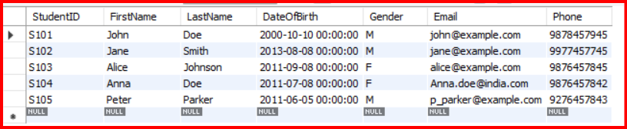

UPDATE Student

SET Email = 'jane_Smith@example.com'

WHERE StudentID = 'S102';

SELECT * FROM Student;

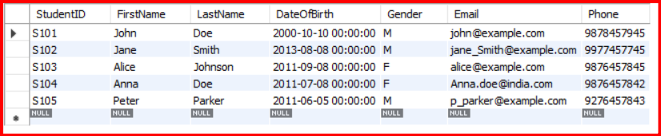

SELECT * FROM Instructor;

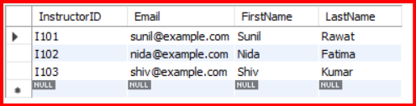

UPDATE Instructor

SET Email = 'sunilrawat@example.com'

WHERE InstructorID = 'I101';

SELECT * FROM Instructor;

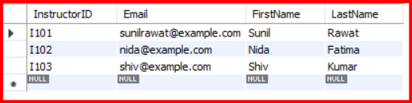

**Task 2:**

SELECT * FROM Student;



DELETE from student

WHERE StudentID = 'S102';

SELECT * FROM Student;

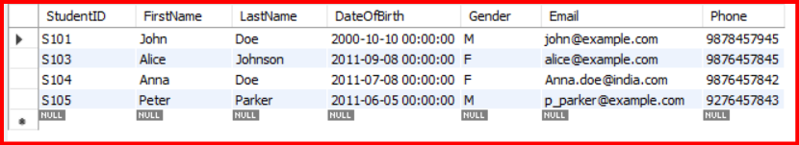

**Task 3:**

SELECT * FROM Student;



SELECT * FROM Student

WHERE FirstName LIKE 'J%';

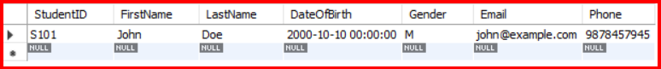

**Assignment 2.**

CREATE TABLE Employee (

emp_id VARCHAR(10) PRIMARY KEY,

first_name VARCHAR(25),

last_name VARCHAR(25),

age int(2),

email VARCHAR(30) UNIQUE

);

**Task 1:**

INSERT INTO Employee (emp_id, first_name, last_name, age, email)

VALUES

(1, 'John', 'Doe', 32, 'john.doe@example.com'),

(2, 'Jane', 'Smith', 28, 'jane.smith@example.com'),

(3, 'Bob', 'Johnson', 35, 'bob.johnson@example.com');

select * from Employee;

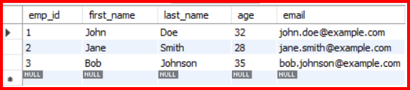

**Task 2:**

SELECT first_name, last_name FROM Employee;

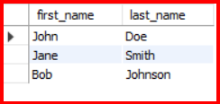

**Task 3:**

SELECT first_name, last_name, age FROM Employee

WHERE age > 30;

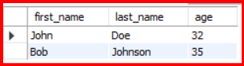

**Task 4:**

**Assignment 3.**

CREATE TABLE BankAccount (

account_id VARCHAR(10) PRIMARY KEY,

account_holder_name VARCHAR(30),

account_balance int

);

**Task 1:**

INSERT INTO BankAccount (account_id, account_holder_name, account_balance)

VALUES

(101, 'John Doe', 50000),

(102, 'Jane Smith', 35000),

(103, 'Bob Johnson', 45000);

select * from BankAccount;

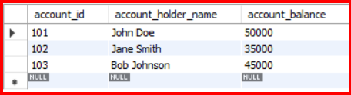

**Task 2:**

SELECT account_holder_name, account_balance FROM BankAccount;

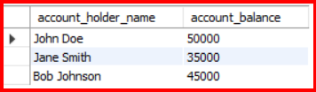

**Task 3:**

SELECT account_holder_name, account_balance FROM BankAccount

WHERE account_balance > 30000;

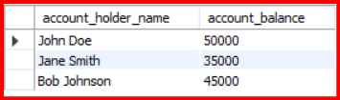

**Task 4:**